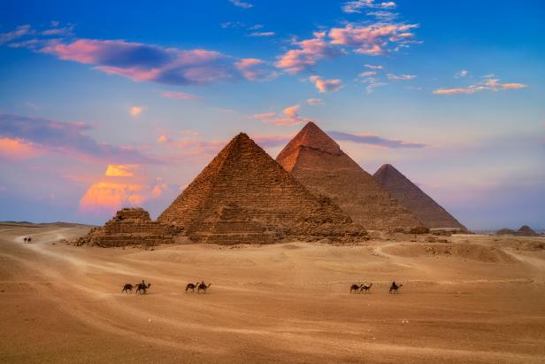

The Great Pyramid of Giza

The Great Pyramid of Giza, also known as the Pyramid of Khufu or the Pyramid of Cheops, is one of the most iconic and well-preserved ancient monuments in the world. It is located on the Giza Plateau, just outside of Cairo, Egypt. Here is a brief overview of the history of the Great Pyramid:

1. **Construction Date:**

- The exact date of the construction of the Great Pyramid is a subject of debate among historians and Egyptologists. However, it is generally believed to have been built during the Fourth Dynasty of the Old Kingdom of Egypt, around 2580–2560 BCE, over 4,500 years ago.

**2.** **Pharaoh Khufu:**

- The Great Pyramid was built during the reign of Pharaoh Khufu (also known as Cheops in Greek), who was the second pharaoh of the Fourth Dynasty. It is widely accepted that the pyramid was constructed as a tomb for him.

**3.** **Architectural Significance:**

- The Great Pyramid is significant for its remarkable architectural and engineering achievements. It originally stood at 146.6 meters (481 feet), making it the tallest man-made structure in the world for over 3,800 years. The precise alignment and precision of its construction have puzzled researchers for centuries.

**4.** **Construction Techniques:**

- The exact methods used to build the pyramid are still debated. Most historians believe that a large workforce of skilled laborers, not slaves as once thought, was employed to construct it. Workers quarried massive limestone and granite blocks from nearby quarries and transported them to the construction site. They used a combination of ramps and levers to move and position the blocks.

**5.** **Purpose and Function:**

- The primary purpose of the Great Pyramid was to serve as a tomb for Pharaoh Khufu. Inside the pyramid, there is a series of chambers, including the King's Chamber and the Queen's Chamber, as well as a complex system of corridors and passageways.

**6.** **Mysteries and Controversies:**

- The Great Pyramid has fascinated people for centuries, and it is surrounded by various mysteries and controversies. Some researchers have proposed alternative theories about its construction and purpose, including ideas related to astronomical alignments and advanced ancient technology.

**7.** **Historical Significance:**

- The Great Pyramid has played a significant role in Egypt's history and culture. It is part of the Giza pyramid complex, which also includes the Pyramid of Khafre and the Pyramid of Menkaure, along with the Great Sphinx. These structures are among the most visited and studied archaeological sites in the world.

**8. Preservation:**

- Despite its age, the Great Pyramid has endured remarkably well over millennia. It has undergone various restorations and conservation efforts to ensure its continued preservation.

Today, the Great Pyramid of Giza stands as a testament to the incredible architectural and engineering skills of the ancient Egyptians and continues to be a source of wonder and fascination for people from all over the world.